**A REPORT ON A THREE-MONTH MANDATORY INDUSTRIAL ATTACHMENT AT EASY BROADBAND (NAIROBI) FROM JUNE TO AUGUST 2019.**

PRESENTED BY:

**ODHIAMBO VICTOR OWINO**

**COM/.042/16**

**REPORT SUBMITTED IN PARTIAL FULFILLMENT OF THE REQUIREMENTS FOR THE AWARD OF A DEGREE IN BACHELOR OF SCIENCE IN COMPUTER SCIENCE SUBMITTED TO THE SCHOOL OF SCIENCE, DEPARTMENT OF MATHEMATICS AND COMPUTER SCIENCE**.

DATE OF SUBMISSION: --------------------------------

**UNIVERSITY OF ELDORET**

**DEPARTMENT OF MATHEMATICS AND COMPUTER SCIENCE**

**DECLARATION**

I hereby declare that all information in this paper has been obtained and presented in accord with scholarly policy and standards. As required by these policy and standards, I have fully written this report based on truth and cited all activities and duties that I undertook while on attachment. I therefore declare that this article is free of plagiarism. Any other copy presented elsewhere without credit to the author shall be defamed plagiarized, null and void.

 Author: **ODHIAMBO VICTOR OWINO**

Reg No: **COM/042/ 16**

Signature………………………………….Date………………………………

**Supervisor’s/Lecturer’s Approval**

This industrial attachment report has been submitted to the department of mathematics and computer science for an award of a degree in BSc. Computer science with my approval as university supervisor.

**Dr. Julius Kogo**

Signature…………………………………. Date…………………………………..

Stamp: ------------------------------------

Department of mathematics and Computer science,

University of Eldoret.

**Industrial Assessor from institution**

DR.MUSEMBI

Lecturer

University of Eldoret, department of computer science

DATE………………………..

Sign…………………………..

**ACKNOWLEDGEMENT**

This attachment was successful due to the cooperation and support of a number of people, who have enabled me gain much more during my industrial training period.

First, I extend my gratitude to all my family members for their support and words of encouragement that they gave me. Special thanks to my mom Iddah Mwai and Velma Owino for the support that they gave me both financially and spiritually. Their constant prayers and well wishes gave me courage to tackle every task in life with hopes of success.

Second and worth mentioning is the invaluable support and guidance I constantly got throughout my training at Easy Broadband. I express my gratitude to the technical team, through them I learnt to embrace teamwork and sharing of knowledge. Special gratitude to my industrial supervisor Mr. Emmanuel Ireri for his remarkable guidance, constructive critics and relevant suggestions throughout my training.

Much thanks to the department of mathematics and computer science. Most importantly to Dr. Julius Kogo: my university supervisor for the constant communication, corporation and supervision of this mandatory industrial attachment programme.

I thank the Almighty God for divine protection, opportunity and guidance that He gave to me during my industrial attachment training period at Easy Broadband.

**DEDICATION**

I would like to dedicate this training report to my parents, beloved friends and to my supervisor Dr. Kogo of University of Eldoret, department of mathematics and computer science for the continuous support and guidance they gave me during the training period at EASY BROADBAND.

**ABSTRACT**

The purpose of this industrial attachment was to create a clear picture of what have been doing, in the form of a report. This field of attachment was a field of practical training experience that prepared me, for experience that prepared me, for the tasks that am expected to perform on completion of my training or after completion of my course of study.

This report contains information which I gathered during my industrial training at EASY BROADBAND for a period of three months. My involvement in this attachment was to make sure that, I acquire new knowledge and practical skills, improving my confidence in problem solving and to utilize the opportunity to relate with different class of people likely to be encountered in factual life situations.

This report gives all the activities I undertook at the company (*easy broadband*), the experience I gained, the practical skills I acquired and the personal inputs to the organization. This report also shows the benefits, success, challenges, and finally, it depicts my reference and the deductions as from the industrial attachment experience.

**TABLE OF CONTENTS**

* Declaration -------------------------------------------------------------------------- i
* Acknowledgement------------------------------------------------------------------ii
* Dedication---------------------------------------------------------------------------iii
* Abstract------------------------------------------------------------------------------iv
* Table of contents -------------------------------------------------------------------v
* List of abreviation------------------------------------------------------------------vi

**CHAPTER 1: INTRODUCTION**

* 1. History of the organization--------------------------------------------------------1
  2. Main functions/ core activities of the organization (easy broadband)-------2
  3. Vision, mission statement and core values of the organization---------------2
  4. Organization structure of easy broadband --------------------------------------3
  5. Responsibilities of the key department at easy broadband------------------4-5

**CHAPTER 2: THE TECHNICAL DEPARTMENT**

2.1 key functions/activities of the department ---------------------------------------6

2.2 main objectives of the industrial training-----------------------------------------6

2.3 assigned routine duties at the technical department-----------------------------7

2.4 evaluation of the attachment report period ---------------------------------------7

2.4.1 Benefits of the attachment exercise----------------------------------------------7

2.4.2 Achievements during the attachment exercise ---------------------------------8

2.5 theoretical achievements acquired -------------------------------------------------8

2.6 knowledge and skills/ learning experience acquired -----------------------------8

2.6.1 Socially-------------------------------------------------------------------------------9

2.6.2 Personally----------------------------------------------------------------------------9

2.6.3 Professionally-----------------------------------------------------------------------9

2.7 discussion on gained experience and skills ---------------------------------------9

2.8 challenges encountered during the training period------------------------------10

2.9 How I cope-up with the challenges-----------------------------------------------10

**CHAPTER 3: CONCLUSION & RECOMMENDATION**

3.1 Conclusion ------------------------------------------------------------------------11

3.2 Recommendation ----------------------------------------------------------------11

3.3 Special remarks-------------------------------------------------------------------12

3.4 APPENDICES--------------------------------------------------------------------12

*WEEK 1 summary* report -------------------------------------------------------------------------------13

Weekly2 *summary* report-------------------------------------------------------------------------------14

Week 3 summary report--------------------------------------------------------------------------------15

Week 4 summary report--------------------------------------------------------------------------------16

Week 5 summary report----------------------------------------------------------------------------------17

Week 6 summary report----------------------------------------------------------------------------------18

Week 7 summary report----------------------------------------------------------------------------------19

Week 8 summary report-----------------------------------------------------------------------------------20

Week 9 summary report-----------------------------------------------------------------------------------21

Week 10 summary report----------------------------------------------------------------------------------23

ICOLO.IO Data center (we visited this data center as part of the industrial training by EASY BRADBAND organization) ------------------------------------------------------------------------------------------------25

Recommendation from the industrial attachment supervisor--------------------------------------------26

**LIST OF ABREVIATION**

* **OLT**-optical line terminal
* **OTDR**-optical time domain reflectometer
* **SPL**-splitter
* **ISP**-internet service provider
* **CTO**-chief technical officer
* **ONU**-optical network unit
* UTP-unshielded twisted pair
* **ODP**-optical distribition point
* **FOSC**-fiber optic splice closure
* **FOST**- fiber optic splice tray

**CHAPTER 1: INTRODUCTION**

***1.1 HISTORY OF THE ORGANIZATION***

The company EASY BROADBAND is an organization that deals with networking (fiber internet). The company was started in 2001 by Mr. Labatt for the purpose of supplying reliable internet.

Mr. Labatt who is now the CEO at EASY BROADBAND started the organization when he finished his college. Basically he started doing maintenance in some companies and also he did support in some companies

After that, he started his own company/organization as an individual. At that time he was installing or using wireless network (*microwave radios and cambium networks*). He purchased his products from micro tick company. His clients mostly were pharmaceutical in that year.

After some years he wanted to advance in his technology from radios to fiber networks. In 2016 he introduced fiber optic role, while the micro technology was still on going, the main Idea which made him change from wireless technology to fiber was that, he saw fiber as a brilliant idea to apply because of its speed and easy maintenance.

Fiber network was the right choice to apply because it’s faster and does not buffer as the radios technology does. After some couple of months he gave his network a catchy name (*plugins fiber/internet).* He also started his offices where he was introducing fiber although he had a hard time i.e. when trying to convince people to try to use his fiber network. When at that time the company was new and had a big competitors like JTL and many other at satellite Nairobi

After a year he got many clients in satellite due to his hard work. After people became aware of the fiber internet speed and also the company’s internet package. He extended the fiber optical cables in Kabiria, along Naivasha road and also in Kawangware. The company grew with more additional clients and finally he opened his office along Naivasha road up to date.

In 2018, clients who were using microwave/ wireless technology started to migrate from radios to fiber network, due to its reliability and speed and also due to its affordable internet packages.

**1.2 OBJECTIBES OF EASY BROADBAND COMPANY.**

The company’s prime objectives are;

* To expand a trusted brand of its products.
* To value additional to bettering clients satisfactory o internet Wi-Fi.
* Adverse on more on its networks around.
* Partnering with potential funding.
* Creating data carriers for hosting servers for clients.

1.3 **VISION, MISSION STATEMENT AND CORE VALUES OF EASY BROADBAND**

*1.3.1 VISION STATEMENT*

The vision statement of plugins fiber is;

* *To create a better everyday connectivity for the many people.*

1.3.2 MISSION STATEMENT

* *Is to provide superior to its technology to its clients that fulfills their wants and needs at the right price.*
* *Culture a knowledgeable and professional staff who will help inspire, educate and innovate solutions to our customers.*

1.3.3 CORE VALUES

Plugins is striving to create a company that foster the following*;*

* Customer happiness

1. Bring a smile on the face of your customers’ credibility.
2. Marinating a 90% customer retention ratio.
3. To become a market leader in innovation and provision of services.
4. To become a cost effective service provider and a cost effective service mode towards the company.

**1.4 STRUCTURE OF THE ORGANIZATION (EASY BROADBAND)**

The management and administration of day to day activities of EASY BROADBEND resides in the office of the CEO, easy broadband. The overall responsibility of the company is vested on the board of directors and director general/CEO of the organization easy broadband

The organization structure of easy broadband is as shown below;

CEO

HEAD OF OPERATIONS

MARKETTING DEPARTMENT

HEAD OF TECHNICAL

STAFF

TECHNICIANS

**1.5 DUTIES AND RESPONSIBILITY OF THE KEY DEPARTMENT IN TH ORGANIZATION**

The following are the departments at EASY BROADBAND and their duties and responsibilities

**TECHNICAL DEPARTMENT**

* Focuses on installation of the new clients in the company. #
* Responsible in any technical work that may arise in the company.
* They are also responsible for maintenance of client’s network/internet.

**MARKETTING DEPARTMENT**

* Responsibly for marketing companies internet packages e.g. the fiber network to the clients.
* Also focuses on new clients to be in the company.
* The department is also responsible in advertising and promotional activities that are aimed in informing potential customers about a new existing products or proposal in the company.
* They are also responsible in designing the product package to ensure that they are appealing to the customers.
* Marketing department is also responsible in responding any complain regarding the customers view on the company product package.

**THE CALL CENTER/RECEPTION**

* Responsible in the telephone service
* Also in charge of receiving call of any clients and giving feedback to the head of technical team
* Responsible in informing clients when to renew their internet before the date of expire, also responsible in mapping clients in the system and giving appropriate feedback.

**FINANCIAL DEPARTMENT**

* Responsible in maintaining the account of the company i.e., income from the monthly pay.
* Also receives customer payment done due to the renewal of the internet and finally due to payment done during the installation of the internet fiber.

**THE TECHNICAL DEPARTMENT**

(*My host department*)

2.1 KEY FUNCTIONS/ACTIVITIES OF THE DEPARTMANT

* The technical department was my host department during my training at easy broadband
* It serves as the core department at the company
* The following are some of the functions of technical department;

1. *The technical department does the installation of the fiber internet.*
2. *It’s also responsible in expanding the network* 
   1. *I.e. running main cables in different apartments and indifferent areas or regions.*
3. *Responsible in supplying the fiber internet to the client’s homes and also in business areas* 
   * *It’s also the one responsible of maintaining the network (plugins fiber)*
   * *It’s also in charge or responsible of the equipment or tools used in the field i.e. it’s responsible in securing its own equipment’s.*
4. *Supplying customers forms or document to be filled by the clients after the installation.*
5. *It’s also in charge of managing the stores*
6. *In the field the technical department is in charge of ensuring that there is safety in the site/in public.*
7. *The department finally is also in charge of receiving and storing any new product in the company i.e. issuing and control; of store.*

**CHAPTER TWO: ATTATCHMENT EXPERIENCE**

**THE TECHNICAL DEPARTMENT**

* 1. KEY FUNCTIONS/ACTIVITIES OF THE DEPARTMANT

The technical department was my host department during my training period at easy broadband. It serves as the core department at the company. The following are some of the functions of technical department;

* The technical department does the installation of the fiber internet.
* It’s also responsible in expanding the network
  + I.e. running main cables in different apartments and indifferent areas or regions.
* Responsible in supplying the fiber internet to the client’s homes and also in business areas
  + It’s also the one responsible of maintaining the network (plugins fiber)
  + It’s also in charge or responsible of the equipment or tools used in the field i.e. it’s responsible in securing its own equipment’s.
* Supplying customers forms or document to be filled by the clients after the installation.
* It’s also in charge of managing the stores
* In the field the technical department is in charge of ensuring that there is safety in the site/in public.
* The department finally is also in charge of receiving and storing any new product in the company i.e. issuing and control; of store.

**2.2 MAIN OBJECTIVES OF THE INDUSTRIAL TRAINING**

The main objectives for the attachment exercise were as follows;

* To access the interests in the occupations i.e. ICT field at large
* To be acquainted with the expectations of working in a highly competitive environment.
* To get opportunity to apply the principles and techniques theoretically learned into real life problem solving situations.
* Enable and strengthen linkages between University of Eldoret (UOE) and various organizations all over the country.
* To make transition from school to the world of work smoothly and to enhance students contacts for job placements.
* To be equipped with practical skills that may not be appreciated visualized or even taught in school like efficient on tasks, problem management etc.

**2.3 ASSIGNED ROUTINE DUTIES AT THE TECHNICAL DEPARTMENT**

The following were the duties I was assigned at the technical department of easy broadband they include;

* Filling documents i.e. writing daily reports e.g. the job done in that specific day.
* Issuing forms to clients and filing them together. The forms contained the following details
* Customer details to be filed by the customer himself or herself.
* Details to be filed by the company management.
* Terms and conditions in the back of the paper.
* Running drop cables to clients (*installation)*
* Splicing
* I was also trusted with the office key I was opening the office in the morning and closing it in the evening.
* I was assigned to buy products or pick them at certain places i.e. I was send to optical Nairobi (*at old mutual building at kimathistreat* ) to buy and pick splitter and OLT
* Taking part in inspection of goods delivered.
* Assisting in running main cable for expanding of the plugins fiber.
* Maintaining cleanses of the office.

**2.4 EVALUATION OF THE ATTACHMENT REPORT PERIOD**

2.4.1 BENEFITS OF THE ATTACHMENT EXERCISE

In the respect with my objectives during the attachment training. The whole process has been all success and all my objectives were achieved as well.

I gained a lot of skills and knowledge during my attachment, I learned a lot of things which includes;

* How to arrange work and also how to write a job card which was signed by the CEO.
* I also learned lots of skills I could not acquire in school i.e. how to relate with work mates and also how to manage the office and the work itself.
* I was also able to acquire new theoretical skills about my field of study which are of high importance to my knowledge and understanding about technical.

2.4.2 **ACHIEVEMENTS DURING THE ATTACHMENT EXERSICE**

From my assigned duties and responsibilities I was able to achieve the following;

* How to do inspection of goods.
* I learned how to behave in an office, and also the dressing code i.e. do’s and don’ts.
* I also learned how to run /install a drop cable.
* How to deliver forms to customs.
* Also I learned how to manage an office.
* How to write a job card after a job is done
* I also learned what I did not know about networking. I got to know and understand couple of things i.e. using optical tools.
* How to handle a ladder in public i.e. public safety
* How to keep records and file them.
* How to crimp an RJ45 cat 5 and cat 6.

**2.5 THEORETICAL ACHIEVEMENTS AQUIRED**

Apart from gaining experience practically I gained some experience from theory work. Which I later put in practice during the field work

The following were learned;

* The steps in fiber optic core splicing and preparation of various types of cables as used in fiber optics network.
* The supplies manual of easy broadband
* Purchase procedure.
* The functions of a fiber optic splitter, Fiber optic splice tray (FOST) and a fiber optic splice closure(FOSC)
* The process of installation.
* Office etiquette i.e. cleanses and maintenance of the office**.**

**2.6 KNOWLEDGE AND SKILLS/ LEARNING EXPERIENCE AQUIRED**

My training exercise has helped me in analyzing my options and my situations. During my attachment period I gained the following skills in different levels;

**2.6.1 SOCIALLY**

* I have gained confidence in greater level through my interaction with the people of different classes and top officials.
* I have also gained interpersonal skills in a good manner.

**2.6.2 PERSONALLY**

* I personally I have gained knowledge about technical and also technical rule as I was mostly working in public, I have learned, on public safety is very important.
* Also team work is a core value towards achievement of any task or work given.
* Finally I acquired problem management skills.

**2.6.3 PROFESSIONALLY**

* Here I heard the opportunity to put into practice what I have been learning in the class including but not limited to; office etiquette in communication skills, WAN, LAN, telecommunication, networking and building and configuration of routers. When and how to give appropriate feedback to the network receiver*.*

**2.7 DISCUSSION ON GAINED EXPERIENCE AND SKILLS**

* One of the most important and obvious goals of attachment exercise is the acquisition of actual real world experience.
* Attachment gives an opportunity to learn firsthand experience that can’t be taught in class and helps us get practical translation of the theory taught.
* My training experience has aided me in analyzing my option and situation.
* The training has individual benefits i.e. brightening the employment chances of the students I the colleges.
* Through this attachment I have gained a good interpersonal skills *(skills acquired/gained while interaction with others)* through my interaction with CEO, supervisor, work colleges and finally the rests of the staffs.
* This has helped me gain courage to interact with people of different classes irrespective of their position.

**2.8 CHALLENGES ENCOUNTERED DURING THE TRAINING PERIOD**

My attachment training experience has been quite good although I faced dome challenges before and as I progressed with my training, though they dint bring me down or make me give up on my way.

Some challenges I faced they are included below:

**Financial challenge**

During the training period of attachment, I had to spent money which I didn’t have, some I had to borrow from my relatives to cater for my lunch and my transport, I spend a lot of money.

**Insecurity**

At some time I was getting home late at night e.g. during support and maintenance, we had to work till the days ticket is cleared despite the time or venue. I remember pretty well a day we worked till 10pm; I would say that God watched over me during my attachment period.

When I was attached we were tiring cables on pole where I had to risk my life tiring cables near live wire, I would say it was risky because I have most of my knowledge in IT and not in power

**Inadequacy of daily work ticket.**

Also during the training there is neither provision to pay interns nor any drafted allowances, packages allowed so as to ease expenses, during the training period and thus catering for the daily expense’s because a burden, as financing may not be adequate.

.

**2.9 HOW I COPE-UP WITH THE CHALLENGES**

Despite the challenges I faced, they gave me an experience and taught me more. I acquired skills in improving my confidence to relate with different categories of people.

The following are some ways I used in solving the challenges I faced;

* I was able to cope with the limited time period I had and work tirelessly to see success in the training.
* *Being proactive*
* There being no much work, I engaged myself in other productive projects and activities relating my career which enabled me gain much experience.
* My father aided in assisting me financially with other of my relatives to the success of my training.
* Our lecture Mr. Brian of orthodox college of Africa used to give us words of motivation to keep up.
* Other thing that made me overcome my challenges is self-awareness I was able to understand myself in different situation that made me cope up.
* I also had confidence facing any challenges and overcoming it. I used to come up with an idea in my head on how to tackle certain problem and come up with a solution.

**CHAPTER THREE: CONCLUSION AND RECOMMENDATION**

**3.1 CONCLUSION**

The supervised industrial attachment of the college give, students the opportunity to apply and put what has been learned in classes into practice. This exposes them to work methods not taught in the class.

It also provides an opportunity for the student to assess their interests in their career been undertaken and also acquaint them with expectations of working in a highly competitive environment.

The training strengthens the linkage between the college and other institution all over the country. In review the training has been a successful and I was able to gain most of it practical skills, I made connection with different types of people.

This attachment with EASY BROADBAND has made me gain much practical knowledge and experience in my field of study (technical)

The training has equipped me with some integrity like being punctual, being submissive to and taking views of supervisors, communication skills and efficient in task and problem management.

As a result, my objectives were well achieved. Not only did I gain practical skill but also acquired Self-managerial and good interpersonal skills.

This training was of good help to me therefore it should be maintained for student to learn more practically as I did and I hope other interns achieve as much as I did.

I was able grow my interest in my career and make transition from what I have been learning from school to the outside world of work.

**3.2 RECOMMENDATION**

The attachment is very beneficial to students as it assists them to bland academic work with that of the industry therefore much emphasis and importance should be given to attachment exercise by the student.

Since the experience for the 12 weeks was enormous, the following should be put in place to better future benefits of students and the institution at large.

* The institution should allow enough time to the student for their preparation and search of their attachment and their requirement as provided by the institution as early as possible.
* The institution should also help the student with a financing institution and look forward to push grants to support their students on attachment.
* The students should be facilitated as it is as the students lack enough funds to facilitate their upkeep during the attachment training period.

**3.3 SPECIAL REMARKS**

* I thank firstly God for His divine protection, because despite of all I faced I came through or I made it safe, throughout my attachment exercise of a period of 3months.
* Secondly I thank the company Easy broadband for the lesson and knowledge that I gained due to my attachment exercise, I also thank Emmanuel Ireri who was our supervisor, for helping us understand the field of networking in the organization.
* This being the final week of my attachment I would say that I was well, equipped with the fiber knowledge of splicing and installation

**3.4APPENDICES**

**-ATTACHMENT TRAINING WEEKLY SUMMARY**

*WEEK 1 summary*

In this weekly report it contains all the work done from Monday to Friday of my first week of training attachment.

The following includes all the experience gained on week one and work done.

* Opening of optical closure
* Arrangement of cores and tubes in a closure
* How to use optical tools like the fiber optic splicer, strippers, cleavers, swap (see in the next page figure 1.2)
* How to manage the tools.
* We also did software installation i.e. antivirus installation.
* I also learned how to crimp an Rj45 using a crimping tool.
* I also learned how to measure power using a patch cord and power meter as shown below.

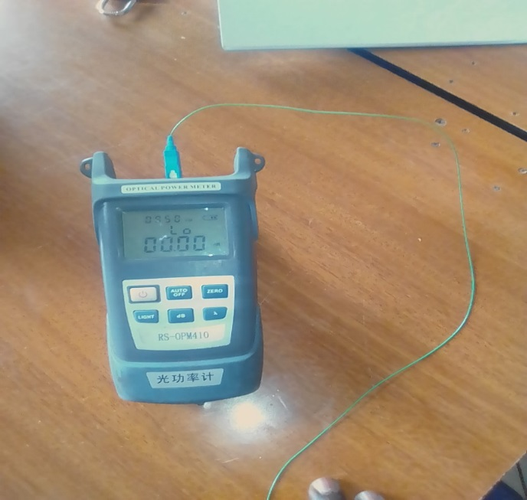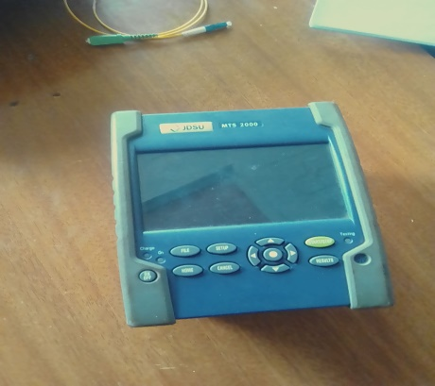

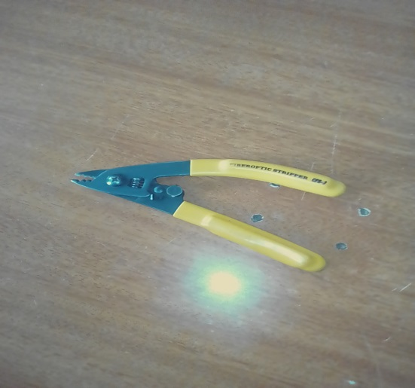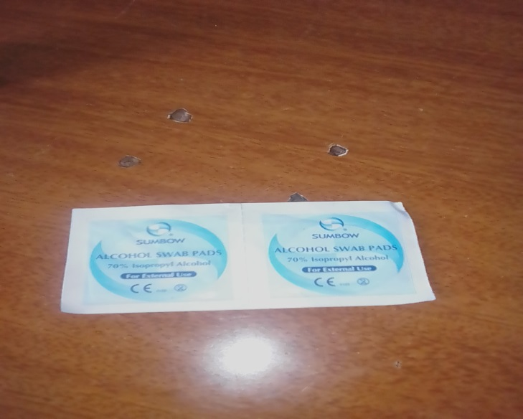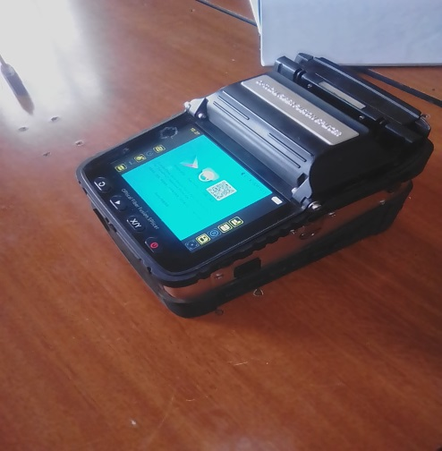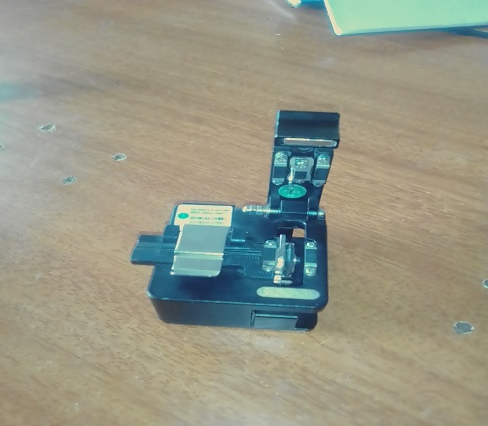

***Figure 1.2 fiber optic tools***

**Weekly2** *summary*

This being the second week, I started to cope up with networking. The following includes work done and experience gained on week.

1. I learned how to run drop cables which and how to manage them from pole to pole.
2. I also got to know how to splice using the splicing machine
3. We did a little bit of installation I got to know and understand a little bit of fiber installation.

I also learned different types of cables 12, 24, 48 core cables etc.

*As shown below figure 1.1*

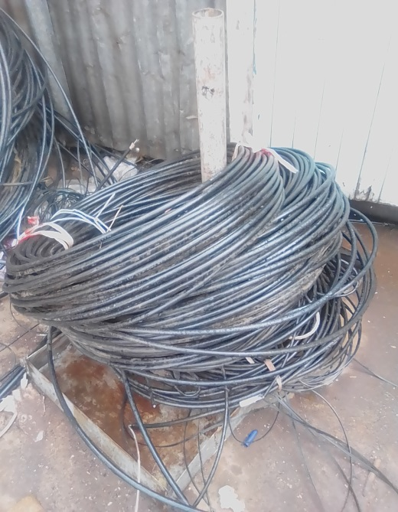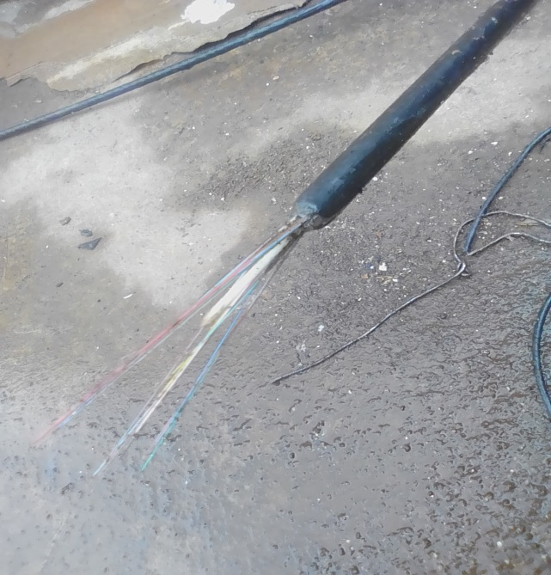

We also learned how to run a main cable from pole to pole.

I was also shown how to patch a patch cord in a connector.

The connector is shown in the next page **figure 1.3**

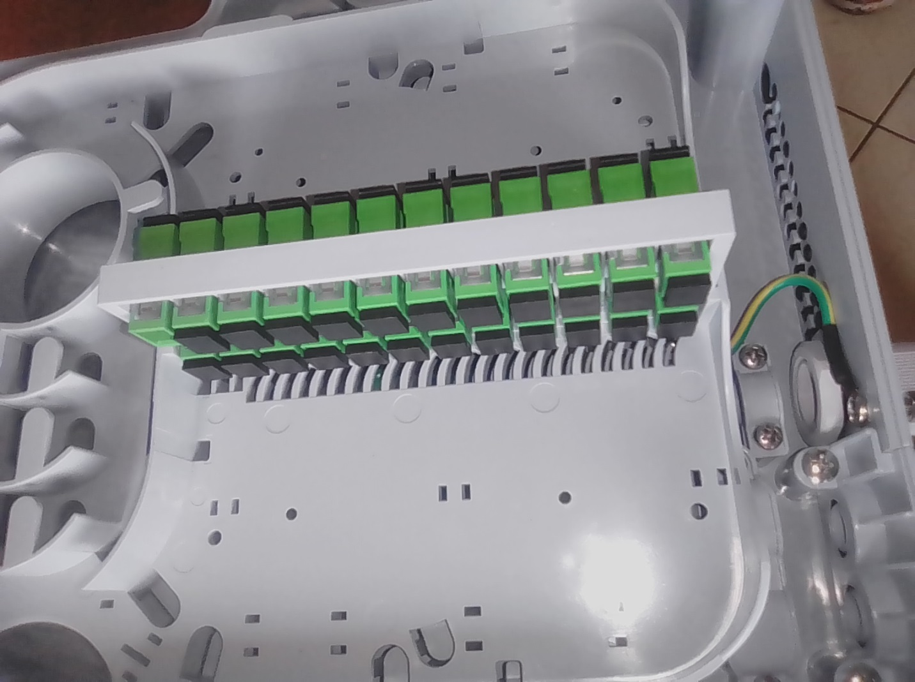

Figure 1.3 Connector in an ODP

**Week 3 summary**

This week I gained lots of fiber optic knowledge this includes;

* *Improving by in splicing*
* *Running of drop cables*
* *Also I improved using optical tools such as strippers, cleaver, laser etc.*

Also in this week I learned how to prepare optical closure in a pole which is (housing of fiber, cores and tubes)

The optical closure is as shown below.

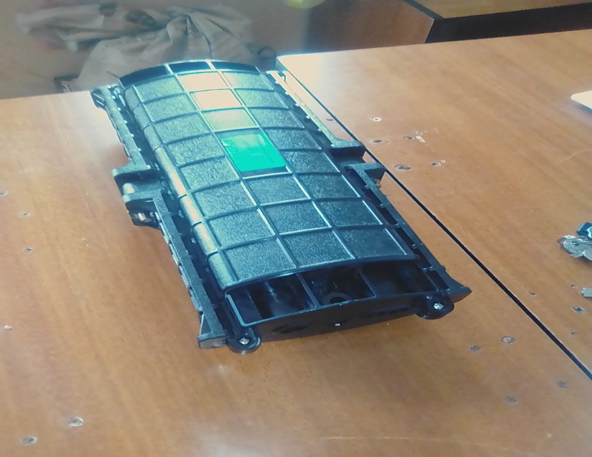

We also did installation of routers in clients home. I learned how to spice cores in a client’s home.

And also we did support (where I gained knowledge in support of fiber)

**Week 4 summary**

This week mostly we did support

Instances which requires support;

* If there is a fiber cut
* Fold of the cable or patch cord
* And finally if the patch cord is covered with dust

I also learned how to use a fiber optic laser

Functions of the optical laser

* Used to identify core from a splitter or from a client’s home etc.

Laser is shown below *figure 1.4*

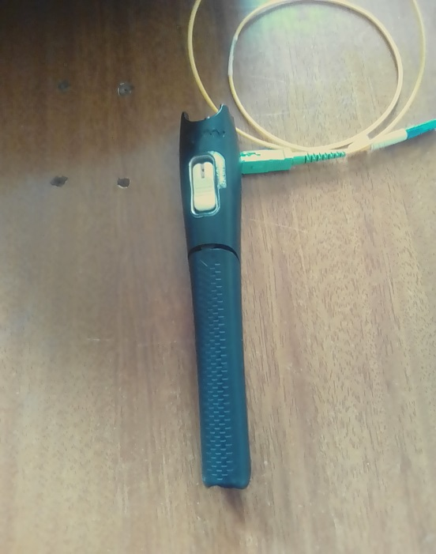

*Figure 1.4 laser*

**Week 5 summary report**

This being the second month I learned a lot and gained lots of knowledge

This week I was able to participate in fiber work include giving out opinions/ideas in the installation due to my cooperation and effort.

I also did few things in computers (*computer hardware*) include RAM installation and also doing service to a desktop.

We were also given lessons on safety in the field includes wearing overalls, reflectors etc.

We also learn how to activate signals from a splitter and also how to install a splitter

An example of a splitter is as shown below figure 1.5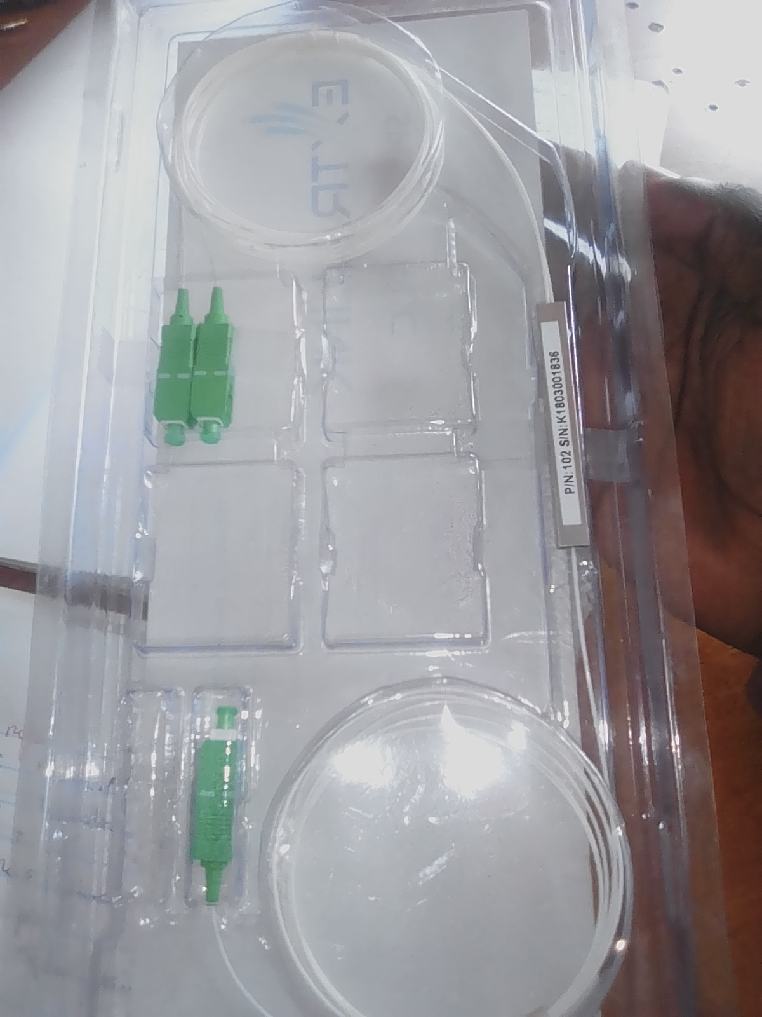

*Figure 1.5 SPL*

**Week 6 summary report**

The week was fine and each task was completed on time, I improve a lot in fiber optics. This includes the following;

* + - Splicing
    - Running drop cables
    - Main cable
    - Cable preparation etc.

**Challenge encounter in the week;**

* Some clients communicated in a rude manner, in places/times of marketing.
* ‘Harsh weather’ conditions because in most cases our work was in the field.

We also did micro wave radio installation, and also support.

An example of a splicing machine includes below *figure 1.6*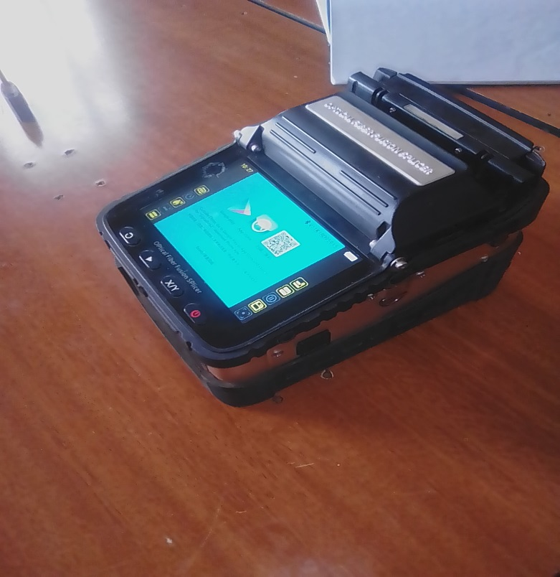

*Figure 1.6 fiber optic splicing machine*

**Week 7 summary report**

This being the seventh week of my training attachment, I had learned a lot, I was able to do installation by myself, in a client’s home we did couple router installation.

Example of a router is shown in the figure 1.7

I also learned how to activate signals from an enclosure.

We also did support in the splitter or from the splitter, and finally we also run drop cable from the enclosure to client’s router

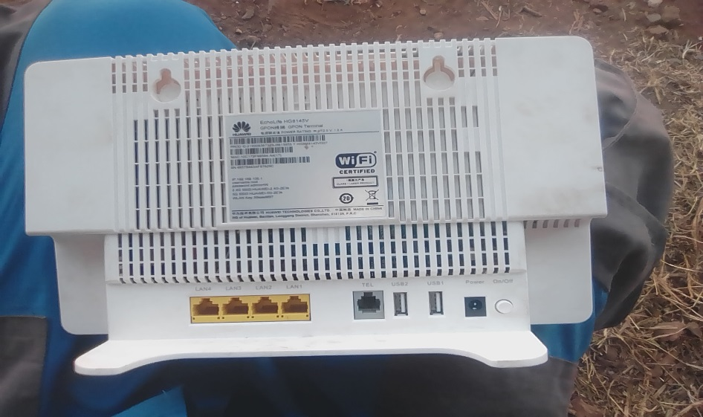

Figure 1.7 WI fi router

*Features of a router*

* *LAN ports 1-4*
* *Power ports*
* *Telephone port*
* *Optical port*
* *Power button*
* *USB port*

**Week 8 summary report**

In this week we learned how to install a splitter in an ODP, where you activate a backbone and splice it with one of the patch cord from a splitter. An example of ODP *figure 1.8*

Experience/skills gained;

* Supervised skills
* Interpersonal skills
* Process of installation
* router installation
* running drop cables
* activating signal
* fiber routing in an ODP

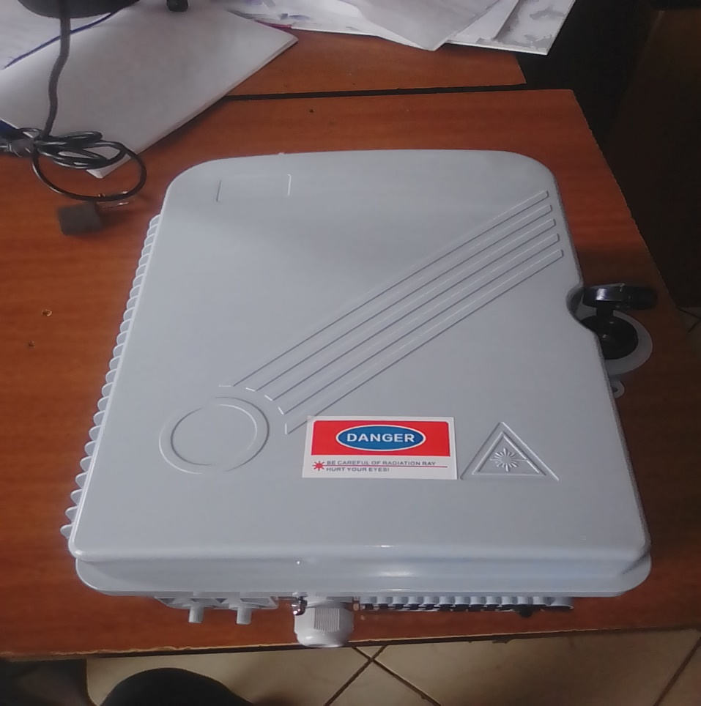

*Figure 1.8 ODP*

**Week 9 summary report**

In this week work was organized on time, and all tickets were planned well and completed at the right time. I learned or I acquire interpersonal skills and also I learned how to operate an OTDR

*Functions of an OTDR*

* It measure losses
* Length of the cable
* Fiber signal strength

OTDR does its function with the help of a patch cord or a pick tail. An example of an OTDR includes in *figure 1.9.*

I also learned about the optical line terminal thereafter abbreviated as ‘OLT’

An example of an OLT includes below and also where it is placed *figure 2.0* and f*igure 2.*1 respectively.

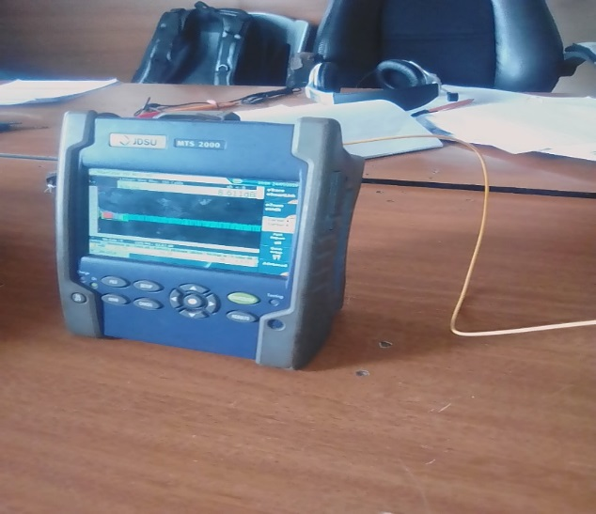 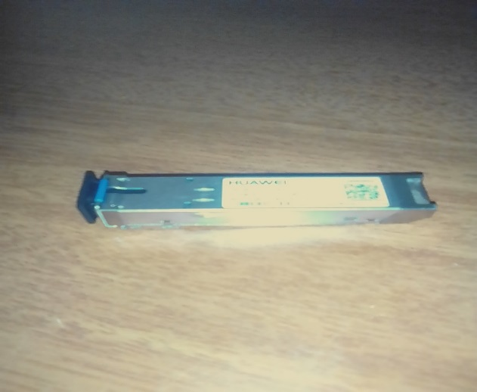 *Figure 1.9 OTDR with a pick tail* *Figure 2.0 OLT*

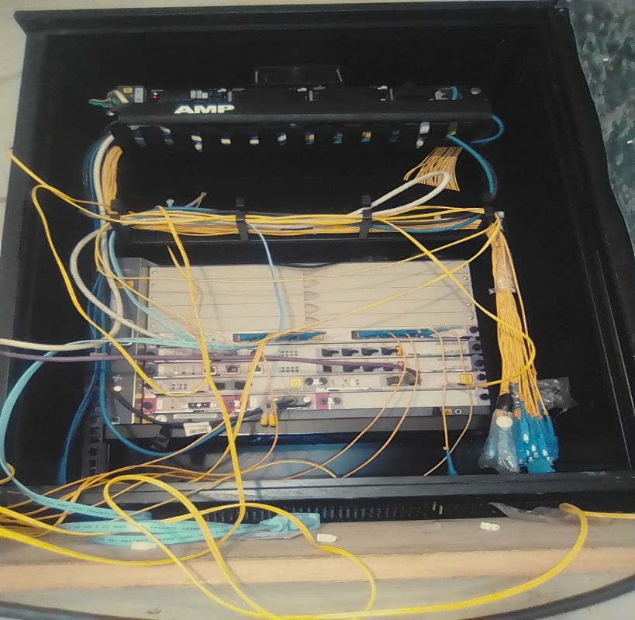

*FIGURE 2.1*

* This is where the OLT is installed.
* This is also where the backbone is being activated.

Optical domain time reflect meter (OTDR) can measure its distance in meter and also in kilometers.

**Week 10 summary report**

This is the tenth week of my attachment training exercise, I acquired a lot of working skills and also behaviors which includes; respecting your colleagues, being proactive, and also interacting with them. I also gained some experience or improved my knowledge in splicing of core from a splitter and also in and enclosure or an ODP.

I also learned how to prepare cables in the enclosure and also, how to prepare a splitter in an enclosure…where we call it end point. The figure 1.10 shows the end point

This being the last second week of attachment training period, I would say that I have learn a lot and gained lots of experience, in;

* Splicing
* Inspection of goods
* Working environment
* Managing a cable, running drop cables
* Being proactive
* Work arrangement
* Supervised skills
* Interpersonal skills etc.

In this week we did installation in the clients home where we,

* Did splicing of cores
* Running of drop cables
* Activation of a splitter
* And finally installation of a router

This week I improved a lot of field work and also office work, I also had challenges but I thank the Almighty for the strength that He have given to me.

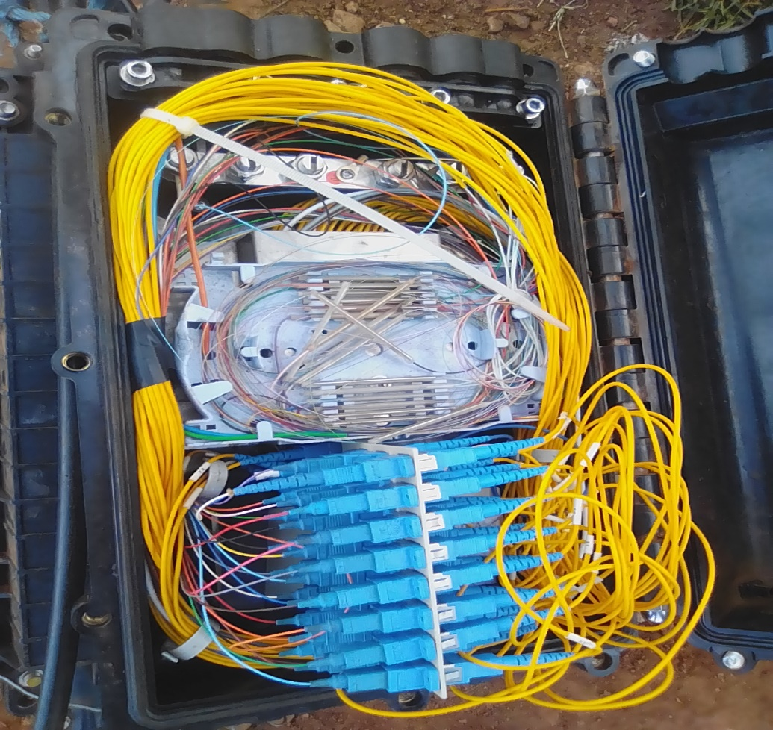

*Figure 1.10 end point*

.